Product Identification


MedCommons Open Radiology™ Gateway User Guide
V 0.5
Part Number 01-0001
May 14, 2004

Copyright Notice
Copyright © 2004 MedCommons, Inc., 52 Marshall St. Watertown, MA 02472

All Rights Reserved. Portions of this document may be put into the public domain under the Creative Commons guidelines.

This user guide has been produced to assist in providing instruction for the MedCommons Open Radiology™ Gateway product. Every effort has been made to make the information in this guide as accurate as possible. The authors of this guide shall have neither liability nor responsibility to any person or entity with respect to any loss or damages in connection with or arising from the information contained in this guide.

Trademarks
MedCommons, Open Radiology, and MedCommons Gateway are trademarks of MedCommons, Inc. Any additional software products named in this document are claimed as trademarks or registered trademarks of their respective companies.

Contact Information
MedCommons, Inc.
52 Marshall St.
Watertown, MA 02472
Phone 617 395 6744
Fax 617 924 5329
www.medcommons.net
mailto: support@medcommons.net

Before you begin…
This software is intended for use by licensed clinical practitioners who are trained appropriately in the software’s functions and applications and are aware of its limitations.
Poor ambient conditions (e.g.: excessive room light), improper display calibration (e.g.: excessive contrast), careless application of image manipulation tools (e.g.: window and level adjustment) and inadequate familiarity with the user interface (e.g.: not reviewing all available information) can all result in incorrect interpretations of an imaging study.

You should also be aware that the image information being processed by MedCommons Gateway™ is potentially incomplete or does not adequately conform to the standards as implemented by the device. To mitigate the impact of these problems, you should take into account the underlying imaging protocols and recognize the potential absence or gross corruption of information.

This device is designed, manufactured and tested to reduce the risk of subtle and serious corruption of labels and image contents. Internal checks and redundant external labels are used to reduce the likelihood of misinterpretation due to internal software errors but these are not foolproof and cannot compensate for bad information coming into the device.

On occasion, interpolated (magnified) data may introduce image artifacts which should not be interpreted as real pathology. When artifacts are suspected, you should be able to change the magnification ratio or window/level setting to help differentiate artifacts from pathology.

System Requirements
Hardware:
Pentium III or compatible processor
512 MB RAM
100 MB Hard Drive Space
Minimum Display Resolution 1024x768 pixels
Color Table Resolution 24 or 32bits per pixel

Operating System
Windows XP
Microsoft IE 5 or higher

Please check the support and help files at www.medcommons.net for the most up-to-date system requirements.

Software License
This License Agreement (“Agreement”) is a legal agreement between you (either an individual or a legal entity) (“Licensee”, “you”, “your”, as context requires) and MedCommons, Inc., a corporation having its principal place of business at 52 Marshall St. Watertown MA. BY INSTALLING, COPYING, DOWNLOADING, ACCESSING, OR OTHERWISE USING THE SOFTWARE, YOU AGREE TO BE BOUND BY THE FOLLOWING TERMS AND CONDITIONS. PLEASE READ THESE TERMS AND CONDITIONS CAREFULLY AS THEY GOVERN YOUR USE OF THE SOFTWARE. If you do not agree to the terms and conditions of this Agreement, please do NOT install the Software and immediately destroy any copies of the Software and Documentation in your possession.

Open Source Licenses
This software is licensed under various Open Source licenses including The GNU General Public License (GPL) Version 2 and GNU Lesser General Public License Version 2.1 as published and Copyright Free Software Foundation,, Inc. 59 Temple Place, Suite 330, Boston, MA 02111-1307 USA.

Source code is available for download directly from the Support section at www.medcommons.net. Individual Copyrights and Software Licenses are determined by the specific contributors of each of the components of this software distribution and can be reviewed as attached to each source file.

Non-Open Source Licenses
Some components of this software distribution are not Open Source. They are licensed by MedCommons, Inc. and, where applicable, its suppliers and licensors in a manner that is compatible with the Open Source components of this distribution.

License Restrictions
You agree that you shall only use the Software and Documentation in a manner that complies with all applicable laws, regulations and the like in the jurisdictions in which you use the Software and Documentation, including, but not limited to, applicable restrictions concerning medical uses and copyright and other intellectual property rights.

The Software or the use of the Software may be subject to legal or regulatory provisions related to products used in the health care. Prior to using the Software, it is your responsibility to ensure that your use of the Software will not violate any legal or regulatory provisions. Please contact MedCommons, Inc. to determine the most recent information regarding legal and regulatory approvals.

Updates and Bugs
MedCommons reserves the right at any time to, but is not obligated to, correct errors, alter features, specifications, capabilities, functions, release dates, general availability or other characteristics of the Software (“Updates”). You agree that you may not have access to such Updates without separate payment or through a separate support agreement. You agree and understand that although MedCommons takes steps to prevent errors, the Software may contain errors affecting proper operation.

Title
MedCommons retains all right title and interest in and to the trademarks, trade names, logos and icons (collectively “Marks”) used in or identifying the Software or its features and you may not use such Marks without the prior written consent of MedCommons.

No Warranty
DISCLAIMER OF WARRANTY & LIMIT OF LIABILITY. TO THE MAXIMUM EXTENT PERMITTED BY APPLICABLE LAW, MEDCOMMONS EXPRESSLY DISCLAIMS ALL WARRANTIES, INCLUDING WITHOUT LIMITATION ANY IMPLIED WARRANTIES OF MERCHANTABILITY, FITNESS FOR A PARTICULAR PURPOSE, TITLE OR NONINFRINGEMENT TO THE MAXIMUM EXTENT PERMITTED BY APPLICABLE LAW. IN NO EVENT SHALL MEDCOMMONS BE LIABLE FOR ANY CONSEQUENTIAL, INCIDENTAL, INDIRECT, SPECIAL, PUNITIVE, OR OTHER DAMAGES WHATSOEVER (INCLUDING, WITHOUT LIMITATION, DAMAGES FOR LOSS OF PROFITS, SERVICE INTERRUPTION, LOSS OF INFORMATION, OR OTHER PECUNIARY LOSS) ARISING OUT OF THIS AGREEMENT OR THE USE OF OR INABILITY TO USE THE SOFTWARE OR DOCUMENTATION, EVEN IF MEDCOMMONS HAS BEEN ADVISED OF THE POSSIBILITY OF SUCH DAMAGES. MEDCOMMONS’ TOTAL LIABLITY FOR ANY DIRECT DAMAGES SHALL NOT EXCEED FIVE DOLLARS ($5.00). BECAUSE SOME JURISDICTIONS DO NOT ALLOW THE EXCLUSION OR LIMITATION OF LIABILITY FOR CONSEQUENTIAL OR INCIDENTAL DAMAGES, THE ABOVE LIMITATION(S) MAY NOT APPLY TO YOU.

Indemnification
The Software is not intended to replace the skill and judgment of a qualified medical practitioner and should only be used by people that have been appropriately trained in the Software’s functions, capabilities and limitations. You agree to hold harmless, indemnify and defend MedCommons, its suppliers, officers, directors and employees, from and against any losses, damages, fines and expenses (including attorneys’ fees and costs) arising out of or relating to your use of the Software. THE ENTIRE RISK ARISING OUT OF YOUR USE OF THE SOFTWARE AND DOCUMENTATION REMAINS WITH YOU.

Termination
This License Agreement will automatically terminate if you fail to comply with any term hereof. No notice shall be required from MedCommons to effect such termination.

Export Restriction
Parts of this distribution may be subject to the limitations on transfer imposed by the United States’ Export Administration Act of 1979 as amended. You agree that you will not, and will not assist or permit others under your control and direction to, export the software or documentation or any part thereof, in contravention of these laws or the related rules and regulations.

Miscellaneous
This Agreement shall constitute the complete and exclusive agreement between the Parties, notwithstanding any variance with any other written instrument submitted by you, whether formally rejected by MedCommons or not. The terms and conditions contained in this Agreement may not be modified except in a writing duly signed by you and an authorized representative of MedCommons. This Agreement is personal to you, and may not be assigned without MedCommons’ express written consent. If any provision of this Agreement is held to be unenforceable for any reason, such provision shall be reformed only to the extent necessary to make it enforceable, and such decision shall not affect the enforceability of such provision under other circumstances, or of the remaining provisions hereof under all circumstances. This Agreement shall be governed by the laws of the Commonwealth of Massachusetts, without regard to conflicts of law provisions, and you hereby consent to the exclusive jurisdiction of the courts sitting in Massachusetts. To the extent that you have breached or have indicated your intention to breach this Agreement in any manner which violates or may violate MedCommons’ intellectual property rights, or may cause continuing or irreparable harm to MedCommons (including, but not limited to, any breach that may impact MedCommons’ intellectual property rights), MedCommons may seek injunctive relief, or any other appropriate relief, in any court of competent jurisdiction.

MedCommons Open Radiology™ Gateway Overview

The MedCommons™ Open Radiology™ Gateway is Open Source Software.

Medical images are increasing in resolution and accuracy and are playing an ever more important role in medical care. Improved resolution and accuracy coupled with increasing computer processing capacity enables enhanced diagnosis, treatment planning and evidence-based medicine.

MedCommons is founded on the belief that public peer review of software and open access to sophisticated software algorithms are essential to managing the next generation of health care software.

In the MedCommons Gateway™, the processing chain from DICOM modality to the physician’s eye is based on Open Source Software and is intended for clinical use.

High-resolution data sets, such as multi-detector CT and modern MRI, increasingly benefit from sophisticated processing to display data quickly and efficiently. Whether as simple as interpolation between pixels or as complex as tracking the location of an aortic stent, image manipulation methods—from the acquisition protocols to the physician’s user interface—are becoming too important to keep secret.

Open Source Software architecture, particularly in the image and image interpretation pipelines, enables peer review and incremental extension of functionality. Because Open Source methods allow for public visibility at all stages of the software life cycle, all bugs are public and innovators are less prone to introducing errors when they re-invent or reverse engineer the functionality of critical subsystems.

Open Source Software also provides powerful components for data interchange and archival storage. Open Source Software protects the data by enabling interchange between vendors even when standards compliance is imperfect, or when vendor-provided support is unavailable.

As a complete image acquisition, management and display device in a format accessible to clinicians, MedCommons provides an Open Source Software alternative to physicians as they take increasing responsibility for understanding and using ever more sophisticated software-based tools.

Indications for Use
MedCommons Open Radiology™ Gateway is a software application for viewing medical images. Typical MedCommons Gateway™ users are healthcare professionals, such as clinicians, radiologists, and technologists.

MedCommons Gateway™ receives, communicates, and displays digital images and data from various types of imaging and image processing system, such as CT, MR, US, RF units, computed and direct radiographic devices, scanners, imaging gateways and image processing sources). MedCommons Gateway™ can be integrated with an institution’s HIS or RIS, linking or transferring images and data into electronic patient records.

Registration and Installation

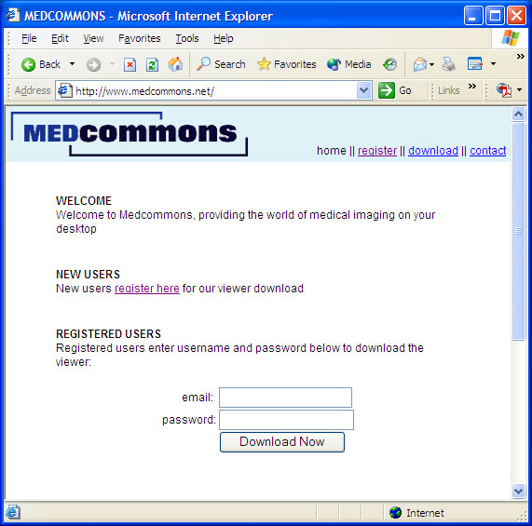

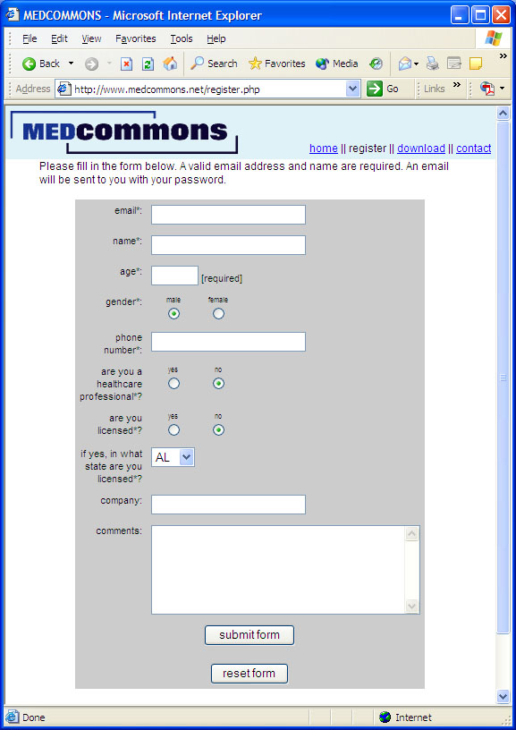

The WADO Viewer

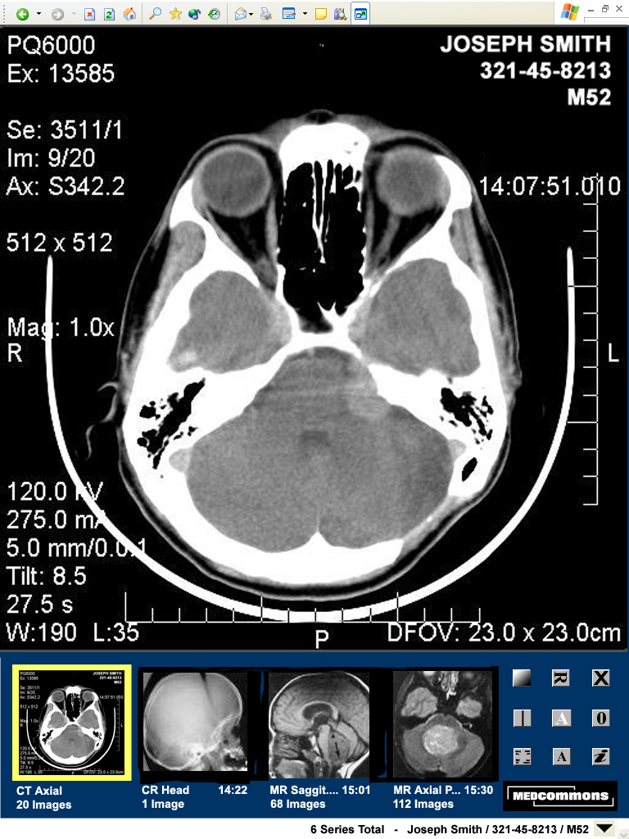

Using the Tools

Image display is controlled primarily by gestures made with a mouse or equivalent pointing tool such as the “pen” of a tablet PC. Some actions have keyboard alternatives.

The two principal gestures are click and drag. A click is typically used to select or activate. Drag is the gesture that draws an imaginary line or rectangle across the screen. Drag gestures are used to indicate a region or to achieve proportional control.

Gestures cause different actions depending on the region (e.g.: image display, thumbnail display, tool palette, menu) of the screen where they are begun. Most gestures provide the user with visual feedback as they are performed.

- Display Menu
A Display Menu at the bottom of the WADO Viewer lists all of the available series for the current patient / study. A check mark next to an item indicates that the thumbnail for that series is currently displayed.

By default (un-clicked) the Display Menu label shows the total number of series available for the current patient and the patient’s identifying information. This feature allows the patient’s name to be displayed in two places in the viewer for safety reasons. Although the WADO Viewer is designed to operate without scroll bars to ensure that critical information is always on-screen, some browser / screen configurations can automatically introduce scroll bars. Operation of the WADO Viewer on a screen with less than 1024 x 768 pixels is not recommended.

Select About… on the Display Menu to display the portion of the SMPTE test pattern that will allow you to check the settings of your monitor.


Clinical applications require a monitor capable of adequate gray-scale range. The test pattern contains 12 discernible squares including two small squares of 95% and 5% density. If, in your viewing environment, your monitor is not adjusted to display all 12 squares, then it is inadequate for clinical use. Adjust the brightness and contrast controls per the monitor manufacturer instructions until all 12 squares are visible at the same time.

- Scroll Wheel
The Scroll Wheel of the mouse controls the displayed image number in all modes. Keyboard arrow keys can also be used to step through images and series.

- Left Mouse Function
The primary mouse button (typically the left button) toggles between two modes of control for Window / Level or Zoom. Clicking the tool icon toggles the mode and changes the icon to match. The Window / Level settings and Zoom / Pan settings apply to the display of all images in a series.

Window / Level
In Window / Level mode, a drag across the image defines a region. On mouse-up, the image will be replaced by a matrix of 9 versions of the region. Each version of the region will be a different Window / Level option automatically selected by the software. For reference, the middle image of the matrix (cell # 5) will be rendered with no change in the Window / Level. The options presented in the other 8 cells may depend on the modality of the originated the image and other information derived from the DICOM image header.

A click on a cell of the Window / Level matrix redraws the entire previous image using the selected Window / Level option. A click on a thumbnail in Window / Level mode selects the new series, replaces the image in the display frame, and applies the current settings to the image series.

A drag on a cell of the Window / Level matrix causes the entire matrix to be redrawn as variations from the selected cell. The region itself is unchanged. The extent of the drag gesture indicates how large a change is desired.

Zoom
In Zoom mode, a drag across the image defines a region. On mouse-up, the image is replaced by a magnified version of the selected region. A frame appears over the corresponding thumbnail to indicate the location of the magnified region. Enabling image overlay displays the magnification factor.

A click on the image window toggles the image between full display and magnified display.

A drag across a thumbnail showing the Zoom region frame pans the frame to adjust the region on display.

Reset
A click on the Reset tool restores the image display for the currently selected series to the initial defaults. This includes Window / Level and Zoom.

Two consecutive clicks on the Reset Tool restores the entire study (all series) and other display modes (e.g.: Overlays) to the initial defaults.

Rotate / Flip
Successive clicks on the Rotate / Flip Tool changes the displayed image in sequence. The sequence is 0◦, 90◦, 180◦, 270◦, Flip Horizontal, Flip Vertical and back to 0◦. Rotations apply to all images in a series.

Overlay Show / Hide
This tool toggles the display of information as an overlay on the image. Patient identifying information (Name, ID, Age, Sex) cannot be hidden. The information displayed depends on the modality, the information received and the current display state.

Examples of display state information include: Image #, Window / Level, Lossy Compression Ratio and Magnification Ratio. Scale Bars, if displayed on the Overlay, reflect the current Magnification Ratio.

Compare
This tool launches another instance of the WADO Viewer and automatically selects the most likely series from the same patient and study for initial display. Depending on screen size, screen configuration and user login preferences, the new WADO Viewer instance can be running on the same computer or another computer.

WADO Viewers launched using the Compare tool are automatically linked with respect to the actions of the Mouse Scroll Wheel for image selection.

Annotation Tools
The Annotation tool changes state in sequence to enable Text, Regions, Arrows and Dimensions to add Annotation Objects to the Annotation Overlay. The Annotation Overlay is associated with a particular image and is not saved once the WADO Viewer is closed or a new Patient is selected.

The behavior of each Annotation Object may depend on the particular browser in use and some tools may not be available in your browser.

Caution: The position of Annotation Objects is automatically adjusted to reflect Zoom and Pan of an image. This action can cause some annotations to be obscured or to change position relative to each other. If the image Magnification and Pan states are changed, it is the user’s responsibility to verify that the annotations still reflect the user’s clinical intent.

Annotations Show / Hide
This tool toggles the visibility of all of the Annotation Overlays in a study.

View HIPAA Log
This tool displays a page of information including security, transfer and warning notices that apply to the current study.

Exit
This tool always removes the current patient from display. Depending on configuration, the WADO Viewer window may stay open with no patient or the next patient and study in a sequence is displayed.

User Feedback

The MedCommons Gateway™ is Open Source Software. Please refer to the Support section of our Web site for an up to date listing of user forums and directions on how to give feedback directly to MedCommons.

MedCommons values your input. Bug reports, feature requests, clinical notes and, yes, even software are welcome submissions. Under the terms of the Open Source licenses associated with this distribution, source code is available at MedCommons.net for most of the functional components. Users with the skill and support to modify and enhance the software are free to do so. However, modification of the Gateway software invalidates the performance, test and labeling protections that apply to the software as distributed from MedCommons. Modification may also impact your ability to get support from the community of users.

MedCommons Gateway™ software is designed, produced and tested in a formal and documented manner consistent with the legal and regulatory requirements that apply to medical devices in this product category. Our procedures include controlled documentation, risk analyses, traceability processes, automated and manual tests and other controls that will not be available to clinicians and engineers in the community. Regulatory approval of MedCommons Gateway™ software applies only to software issued to MedCommons, Inc. Redistribution of MedCommons software, whether commercial or not, without regulatory approval is illegal in the US, Canada and most other countries. Please contact MedCommons for additional information on how to meet regulatory requirements or to discuss the inclusion of your software in future versions of the MedCommons Open Radiology Gateway.

3. Images
The MedCommons Gateway™ software does not know the extent to which an image has been processed before it is received. On-image labeling about processing may be misleading. For example, MedCommons Gateway™ could indicate that an image has not been processed, when in fact it had been processed extensively prior to its receipt. The following labeling is in the Users Guide:

The user should also be aware that the image information being processed by the device is potentially incomplete on does not adequately conform to the standards as implemented by the device. To mitigate the impact of these problems, a qualified user is expected to take into account the underlying imaging protocols and to recognize the absence or gross corruption of information.

This device is designed, manufactured and tested to reduce the risk of subtle and serious corruption of labels and image contents. Internal checks and redundant external labels are used to reduce the likelihood of misinterpretation due to internal software errors but these are not foolproof and cannot compensate for bad information coming into the device.

On occasion, interpolated (magnified) data may introduce image artifacts which should not be interpreted as real pathology. When artifacts are suspected, the trained user may be able change the magnification ratio or window/level setting to help differentiate artifacts from pathology.

